UKG Ready: Payroll Clerk & Managers Guide
All Supervisor Tasks 2
My Team Tab 2
Approve/Reject/Edit Time Off Requests 4
View/Edit Employees’ timesheets 5
Add/Edit Overtime 6
Punch employee In/Out 6
Adjust punches 6
Reports 7
View reports 7
Save/Export reports 7
Create new reports 11
Employee Tasks 15
Approving Overtime Requests 15
All Employee Tasks 16
Go Back to Home page 16
View Menu / Pin Menu 17
View/Edit Employees’ timesheets 18
View Current timesheet 18
View Historical timesheets 19
Request Overtime as Comp time 21
CTO 25
Punch In/Out 27
Request Time off 28
View Employee Profile 31
Payroll Clerks Tasks 32
Approving Timesheets 32

All Supervisor Tasks

My Team Tab
With supervisor level access you have two tabs on your homepage.
Myself: to interact with your personal data.
(Explained in detail in the Employee section of this guide)
My Team: to interact with your teams data as a supervisor.
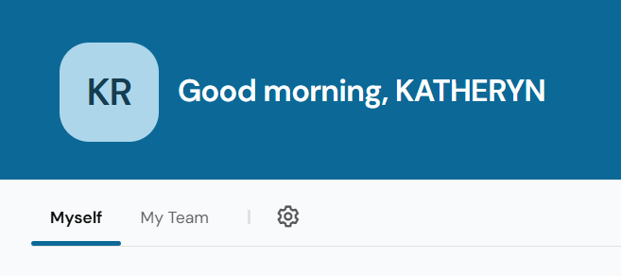
You’ll see your Quick links in the My Team tab are aimed more towards the supervisor role. You’ll see your team in the middle as well as timesheet tasks. You can click each of the headers to view that specific page.
The Timesheet Tasks section can be used to quickly approve/deny timesheet changes or time off requests. Select the numbers to pop out a menu to view a list of those tasks.
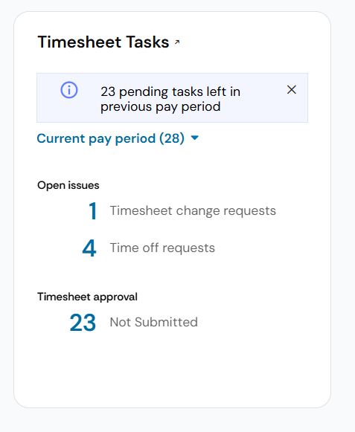
In the popup you can approve or reject the requests individually. If you select multiple checkboxes, you can approve or reject them all at once by using the Reject/Approve buttons at the top right.
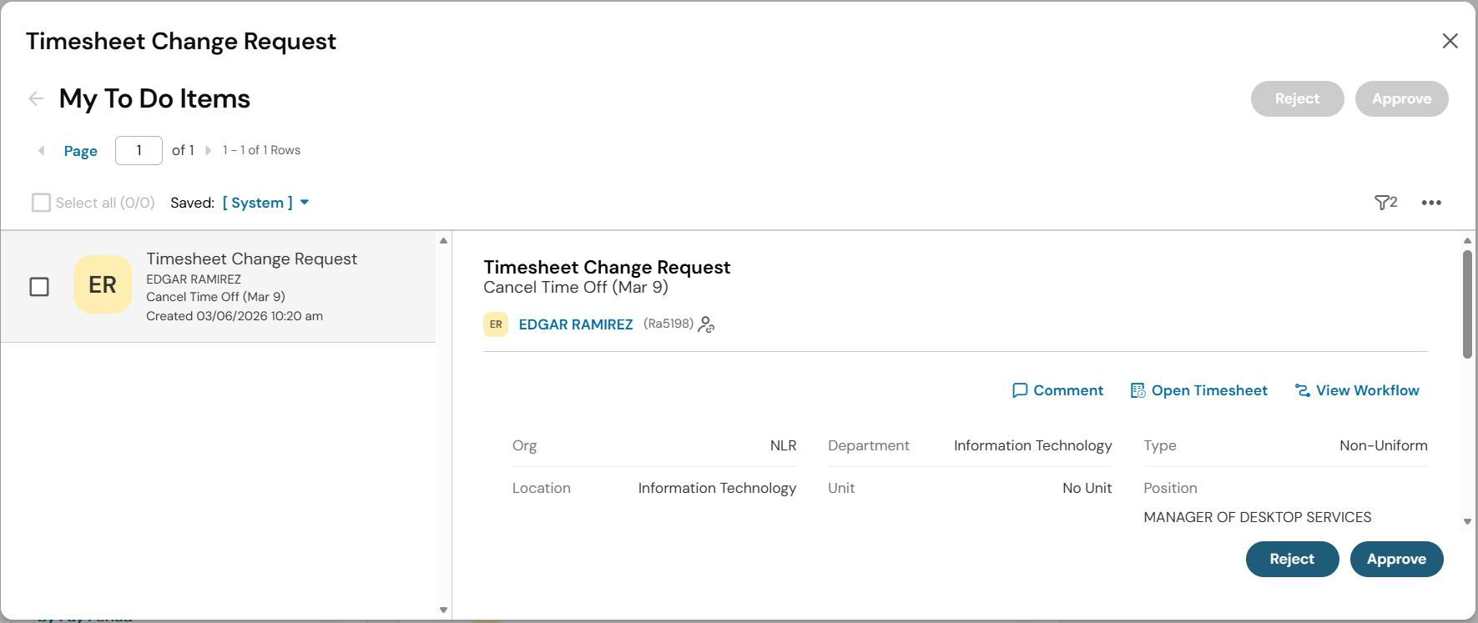
You approve the request then you’ll see the ITEMS TO RESOLVE menu, in this menu you NEED to check the appropriate box as employees regular hours are PRE-POPULATED. Most of the time you will remove the NON (all) option, just selecting the hours you are approving. Select the check box and then approve the time off request. If a request spans multiple days, there may be multiple warnings displayed. You will need to click on each day's warning to make the appropriate decision before continuing.
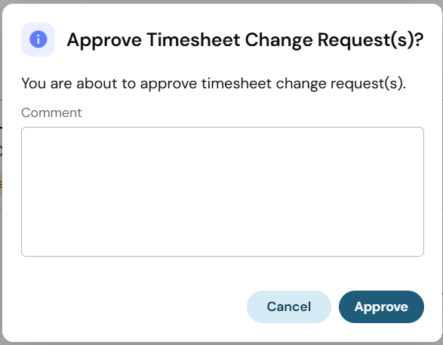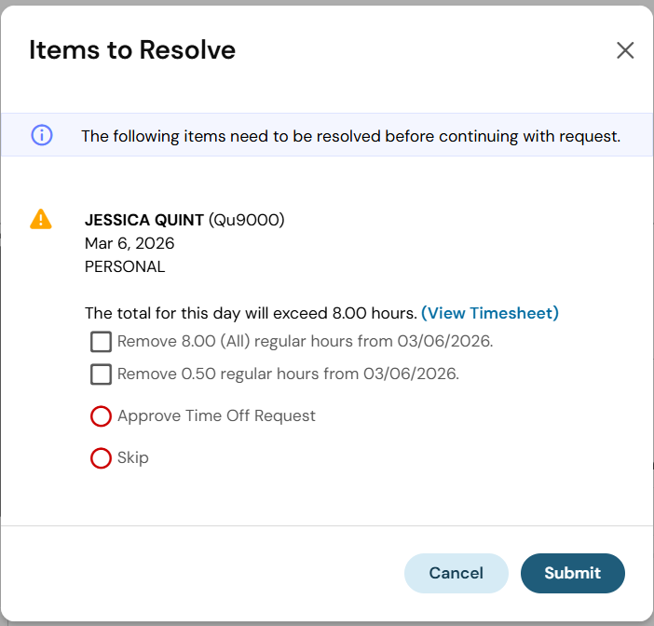
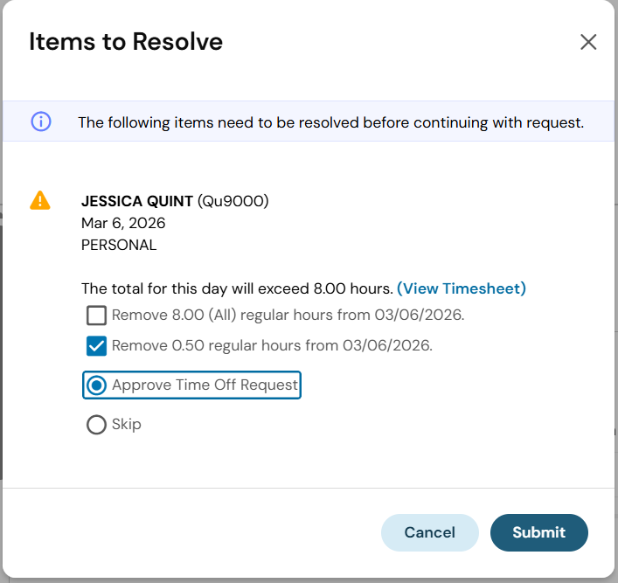

Approve/Reject/Edit Time Off Requests
Alternatively, you can use the Hamburger menu to open this menu, select TEAM > Time > All Open.
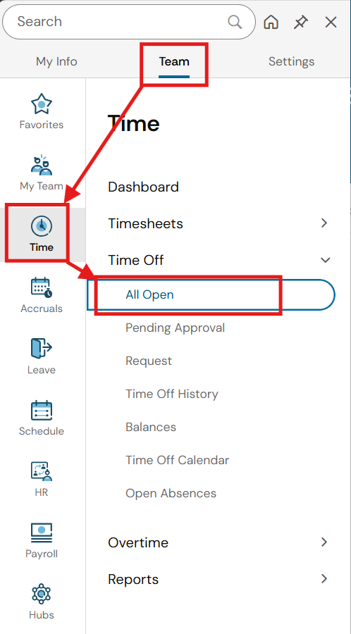
Select the time entry, approve/reject as required.
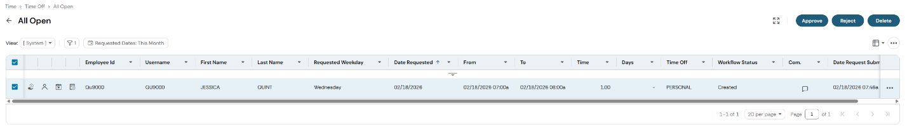
You can also Edit/Adjust the submitted time using the triple dot on the far right of each request, and then modifying the request.
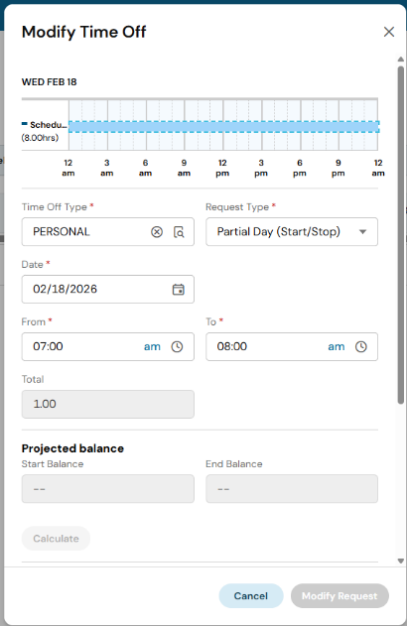

View/Edit Employees’ timesheets

Easiest method is to type the name of the user you are aiming to look at, then click the Person Paperclip icon on the right.
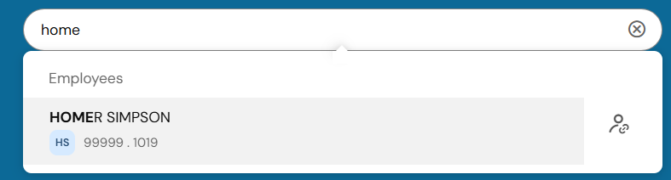

Select Current Time Sheet.
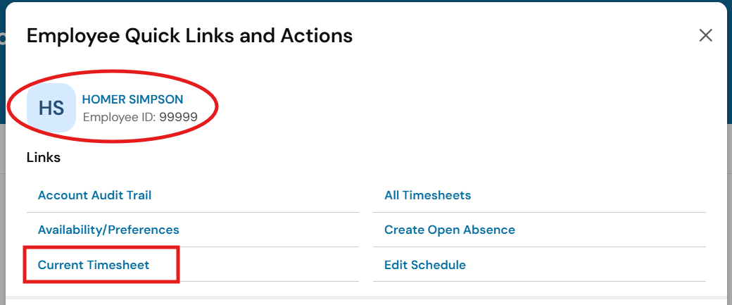
OR go to the hamburger menu, Team > My Team > Team Members.
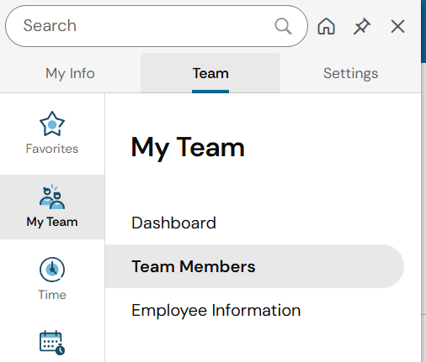

Add/Edit Overtime
The method to add overtime is the same as for users. See Request Overtime as Comp Time.

Punch employee In/Out
You can request adding a time entry if the user is completely missing their clock in/clock out. If there is already an entry in the timesheet see the adjust punches section.

Adjust punches
You can view the user’s current timesheets by searching for the user, clicking the Person Paperclip Icon then View Current Timesheet. Here you can adjust their clock in/out time and SAVE it.

Reports
You can go direct to the Report Hub using the hamburger menu, My Reports > Report Hub.
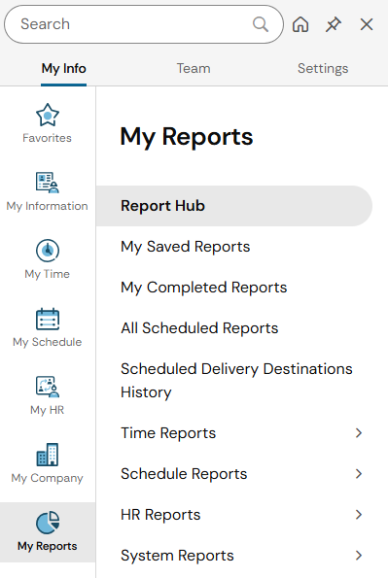

View reports

The recommendation is to check the Quick Links field on your team profile. These have multiple pre-setup reports that you can select in blue. Overview or my Saved Reports is recommended.

Save/Export reports
When trying to export a report, go into it and then select the triple dot.

Select Export
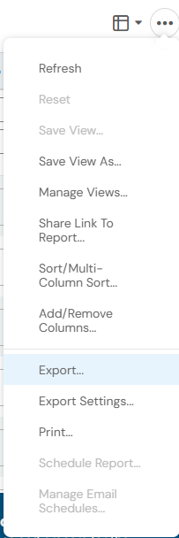
Excel 97-2007 will give you an XLS. Excel 2000 will give you XLSX. Export as required.
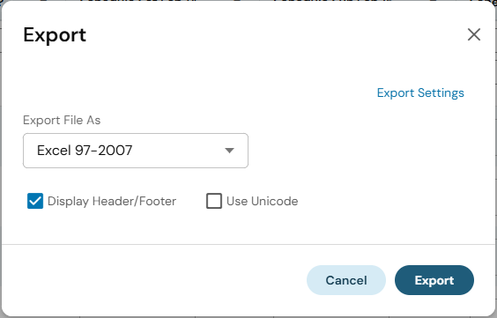
Certain reports such as the *TB reports cannot be saved using the above method.

You need to select the employees you are running the report for. Double check the Time you are running the report for.
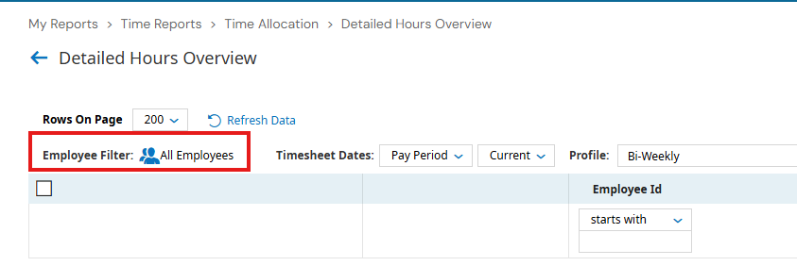

You will get a menu with this header, select the check boxes by the employees ID’s or select the check box at the top by the filters. Then hit ADD Selected. Then Use Filter.
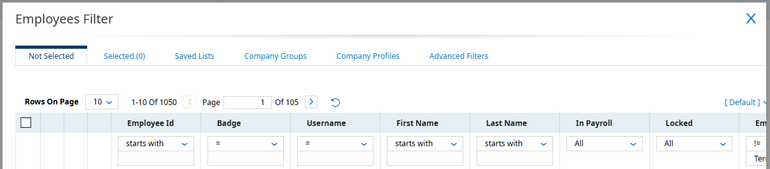

The report will populate with the employee data you selected.
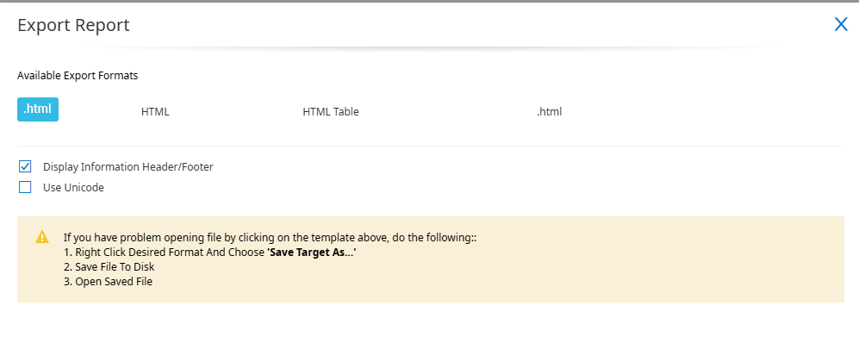

Click the HTML option. Then when it finishes populating right click and print.
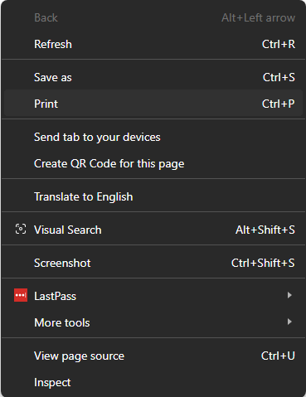

Save as PDF to the folder you require this saved in.
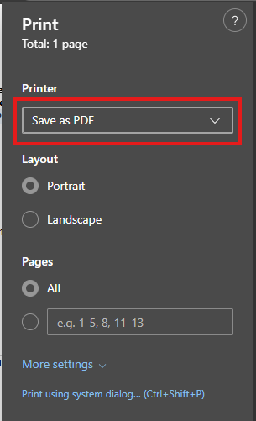

Create new reports
Go into the Report Hub as explained in the previous steps. There should be a Build Report along the top.
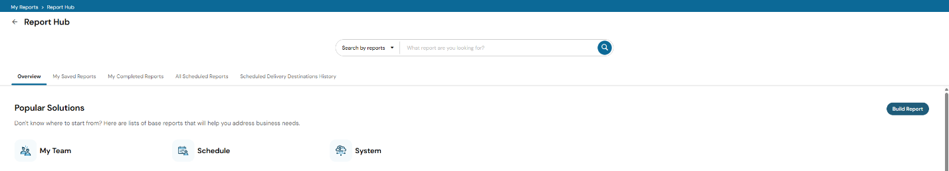
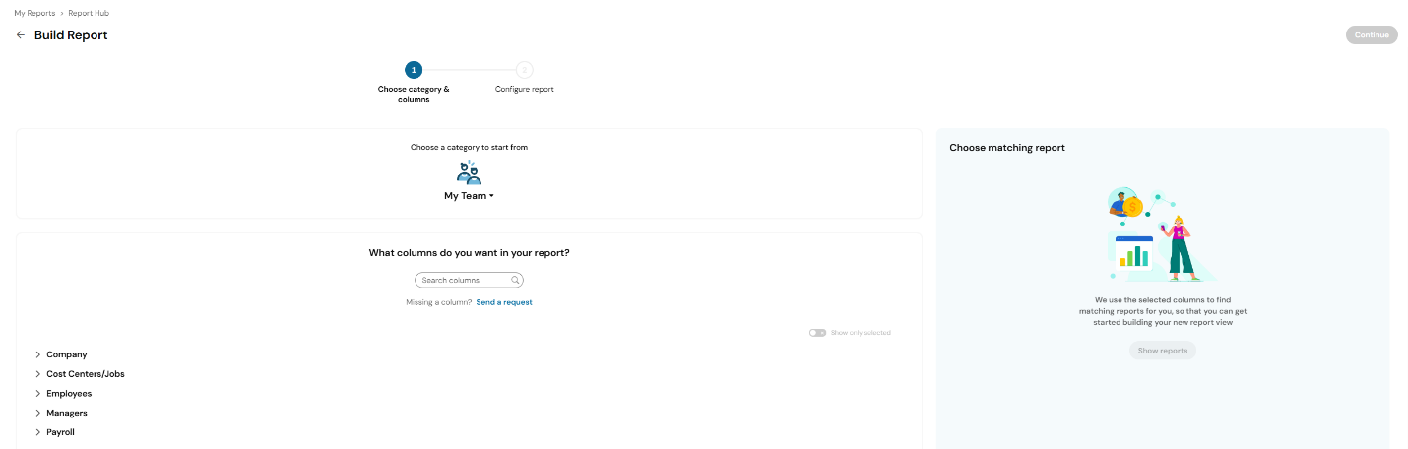
Choose the Category to start from by clicking on My Team under the people icon. This will adjust the columns available for the report.
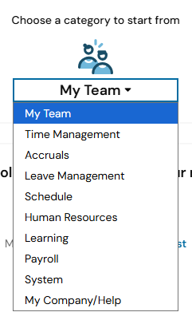
When you select options, it will try to show you reports.
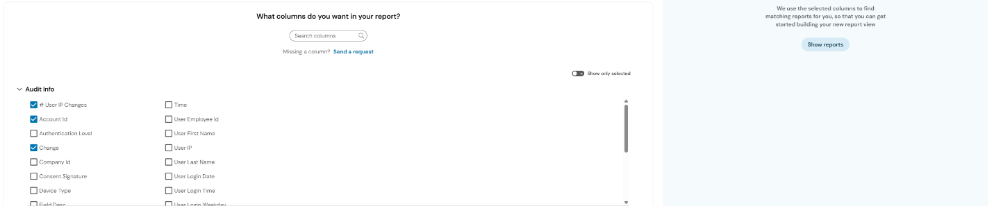
Click the Show Reports button.
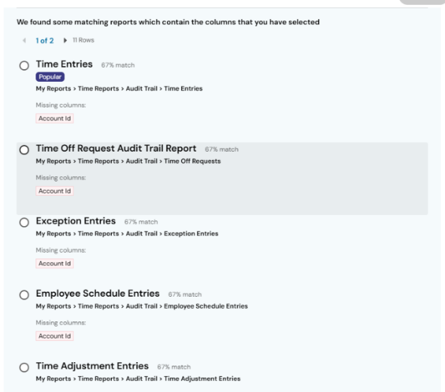
If you select one, then the continue button, you will receive the following pop-up. Clicking Yes will get you a brand new report.
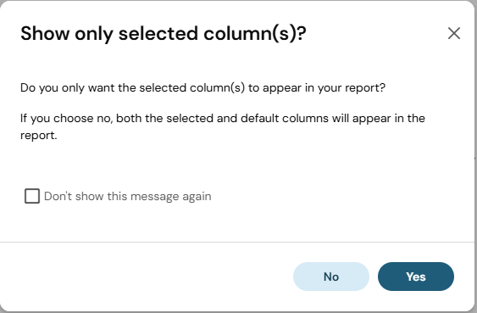
Click the Pencil icon by the title to update the name and description. Quick actions Edit Report Settings is the same.
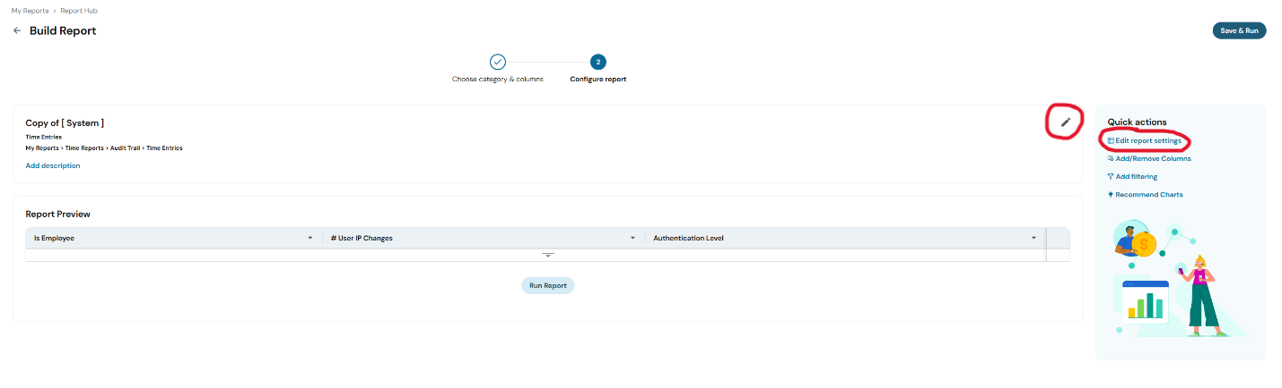
You can add or remove columns. Select a column on either side and the applicable buttons will highlight.
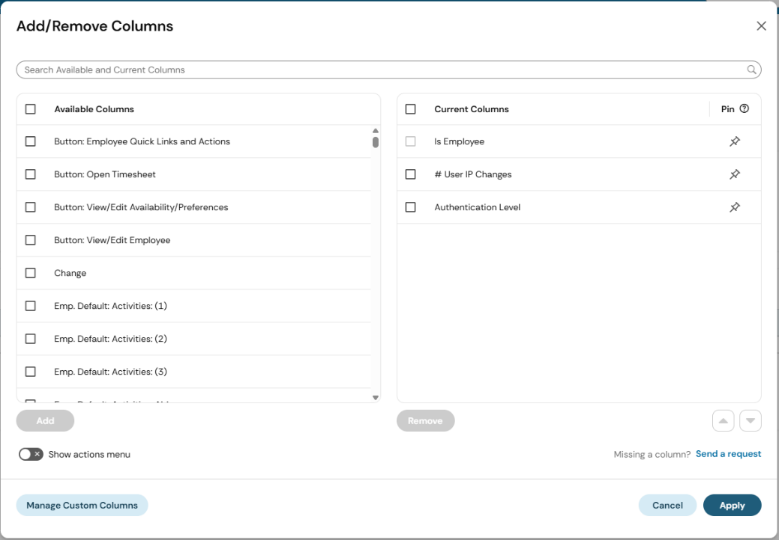

Filters for the reports are available by clicking Filters in the quick links.
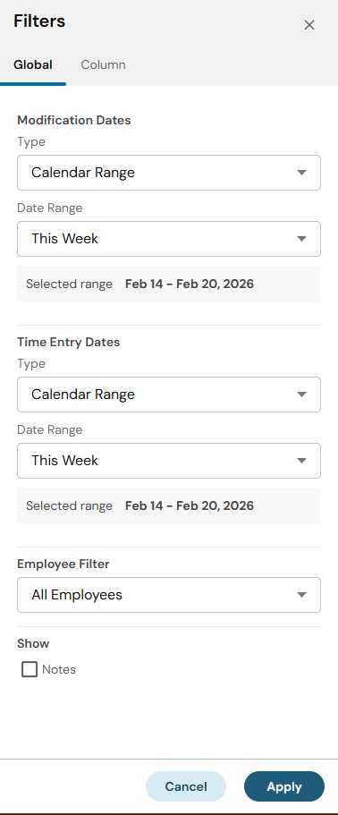
You can click the RUN at the bottom to preview the report without saving it. Save and Run will load the full report. You can then delete the report by going back to My Saved Reports.
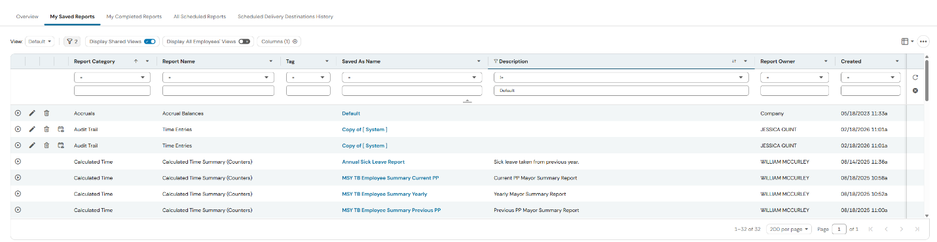

Employee Tasks

Approving Overtime Requests
Using the hamburger menu click the Team Menu > Time > Change Requests > Pending Timesheet Change Requests.
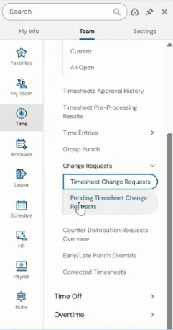
Any pending requests will be listed below. Select the check box and hit approve or reject as required.
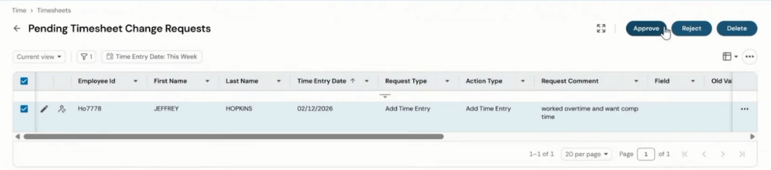
Type any accepting comments – Note: Users will not see these comments in their timesheet – and click approve.
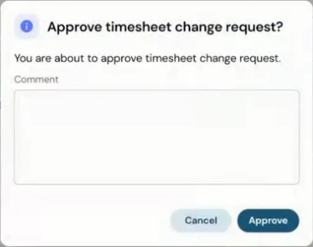

All Employee Tasks

Go Back to Home page
To go back to the Home page, you can click on the UKG logo. Alternatively, from the Menu (3 stacked lines) on the top left side of the screen, you can click the Home icon.
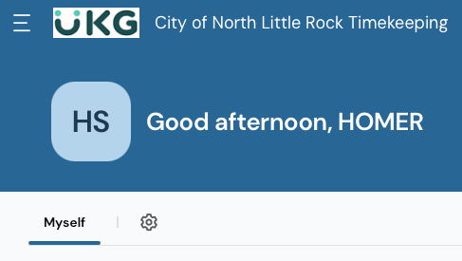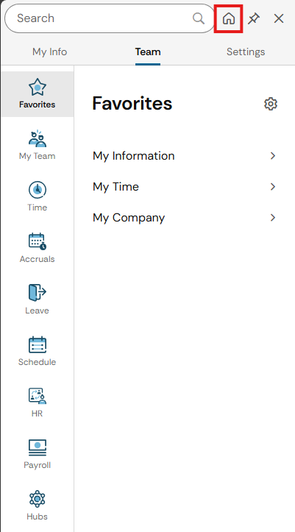

View Menu / Pin Menu
To view the Menu, you can click the 3 stacked lines on the top left of the page. To make this menu stay open, you can choose to pin it by clicking on the pin icon.
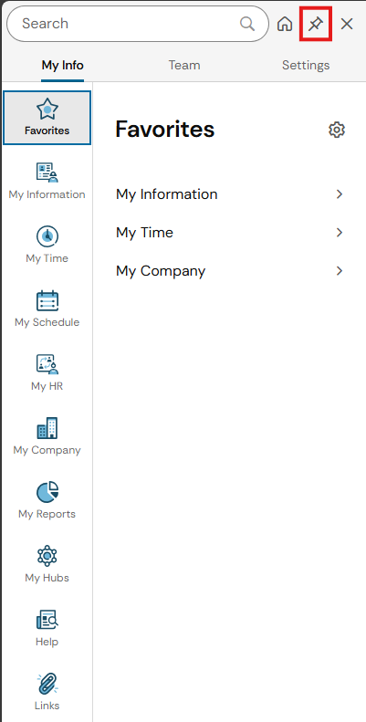
To unpin the Menu from the side, you can click the pin icon that was used to pin the menu.

View/Edit Employees’ timesheets

View Current timesheet
To view your current timesheet, click on View My Timesheet in the Clock widget on the Home page. Alternatively, you can go to the menu, click on My Time > Timesheet > Current Timesheet. 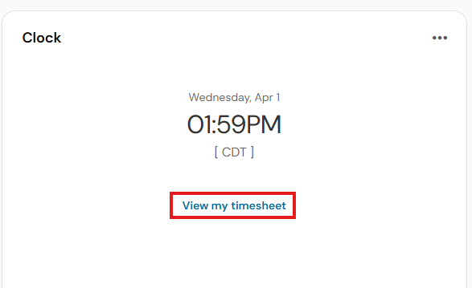 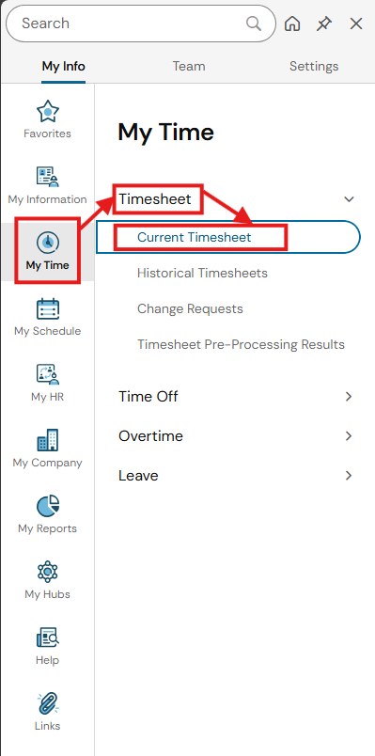

View Historical timesheets
To view your historical timesheets, click on Historical Timesheet in the Links widget on the Home page, then click on My Historical Timesheet. Alternatively, you can go to the Menu, click on My Time > Timesheet > Historical Timesheets.
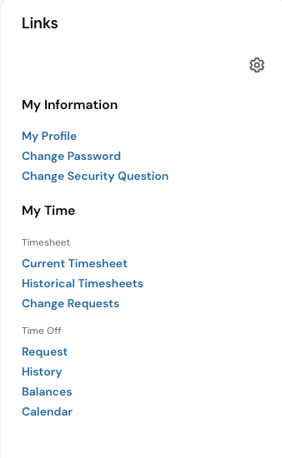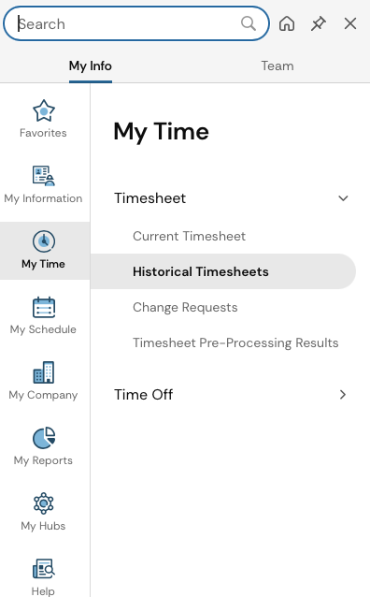

You will get a list of historical timesheets. You can click the pencil icon next to the one you want to view. If you want to view multiple, you can select the checkboxes next to the ones you want to view, then click on View at the left of the page. Note: if you don’t see the timesheet you’re looking for, there may be several pages of timesheets. You will need to page through them to see more.
Option 1: View a single timesheet. Click the pencil next to the one you want.
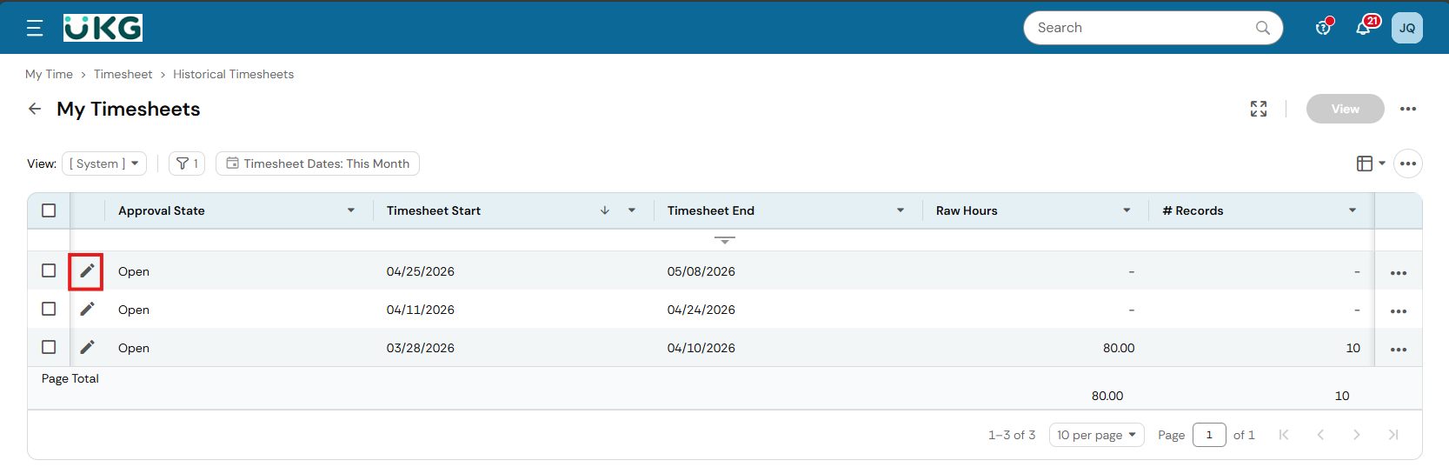

Option 2: View multiple timesheets. Check the checkbox next to the ones you want to view, then click View.
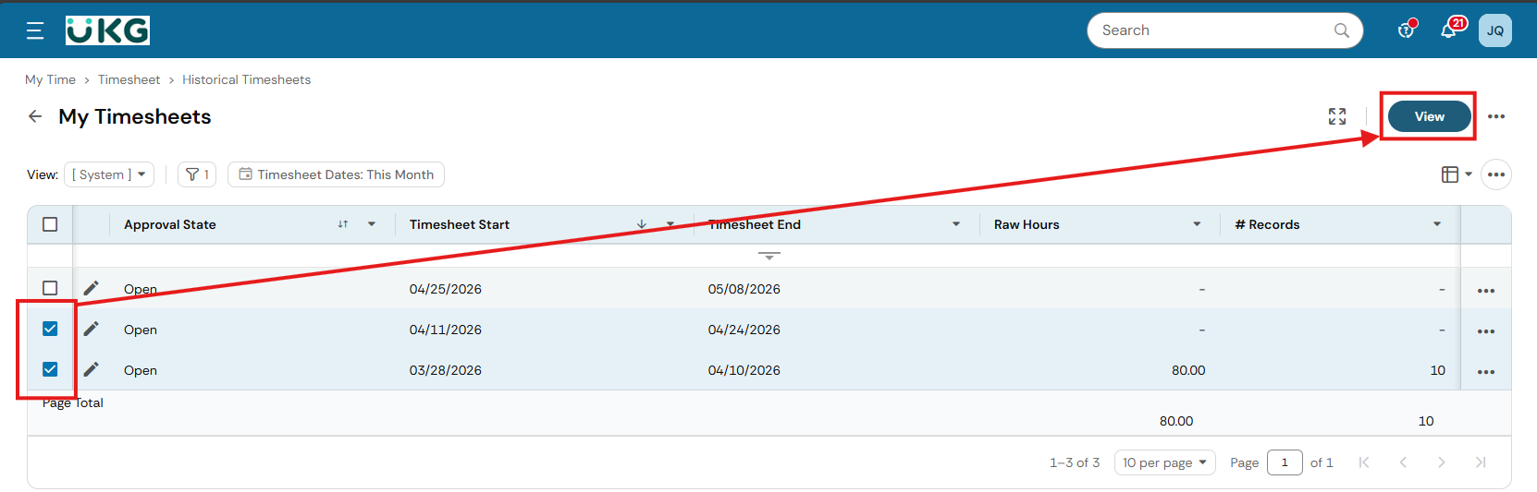

Request Overtime as Comp time
On the home page you can click the View My Timesheet button.
Select the Change Request.
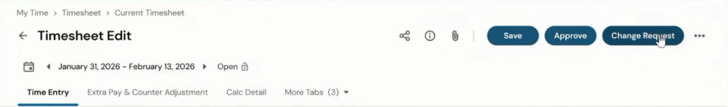
Select Add Time Entry. Fill out the Date, TOTAL and Comment. Select the drop down arrow to select an Activity. If you are looking for a specific activity and cannot find it, select Browse in the drop-down menu.
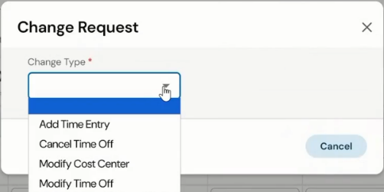
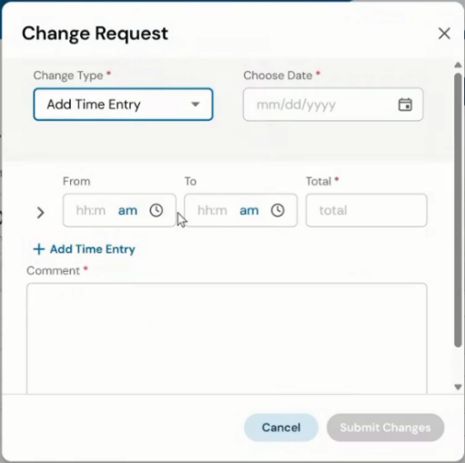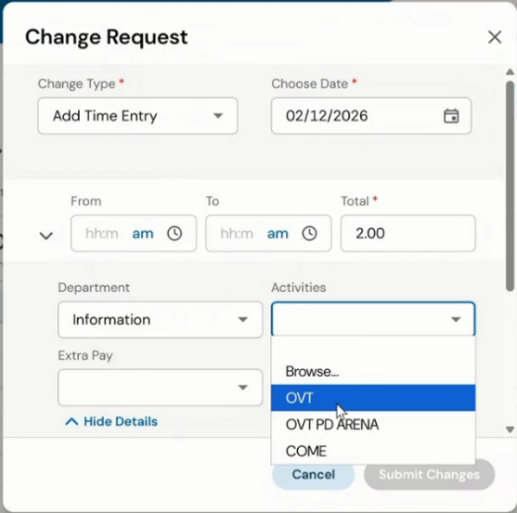
Scroll through the list for the wanted type.
Note: If no time has been taken off for the week, COME is a valid selection. If time has been taken off, pick COME_ST. OVT for standard over time as your department permits.

* Note for PD Users – The Browse and Select Cost Centers selection is where you can find the Dollar general/other OT options. You can browse the list or tree view.
* Note for OESN Users – This is where you would add the OESN.
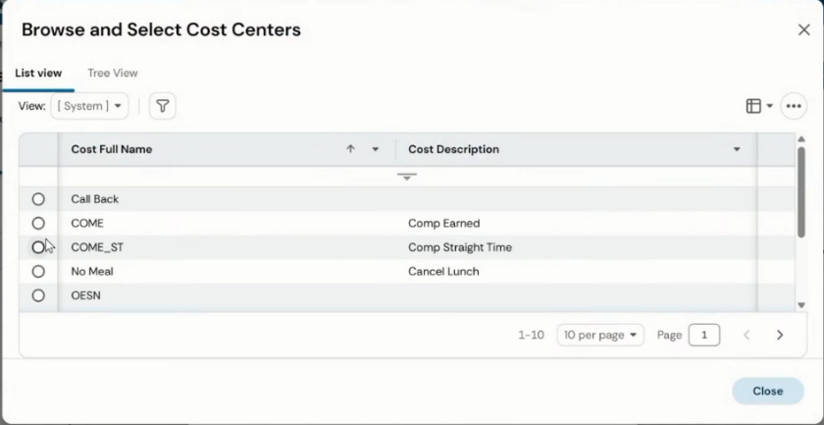
When entering time, enter it as the exact hours worked. BSA will run the calculations based on the type.

Once you submit changes you will not see the request on your time sheet until it is approved. If you need to check or adjust the submitted entry select the Hamburger menu (triple line) at the top left and go to Change Requests.
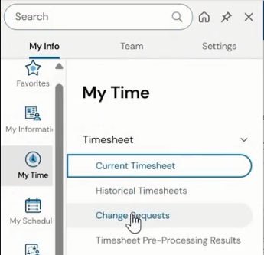
You’ll see one or many requests that haven’t been approved yet. You may adjust it from the TRIPLE DOT on the right, or the EDIT pencil on the left.
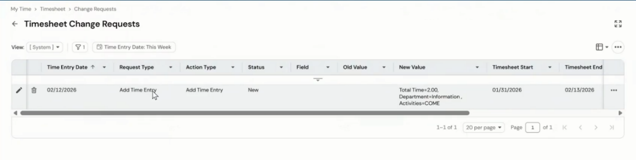
As a supervisor, the submitted timesheet change request can be found in the Hamburger Menu (Triple line). Team > Time > Change Requests > Pending Timesheet Change Requests.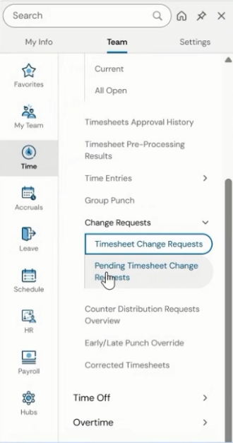
Select the change request you would like to submit, then approve.
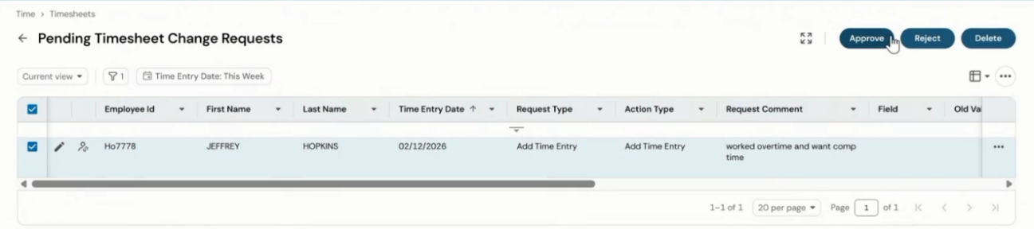
Add a comment if required, the end user will not see this comment.
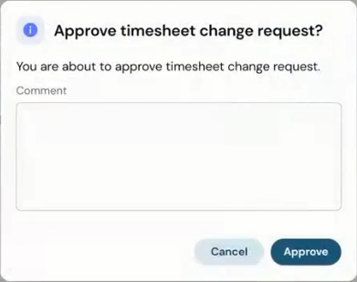

CTO
To submit your CTO time you need to create an entry on your Timesheet directly. You can access this on the main menu, on the clock, select View my timesheet.
Click Change Request.
Then in the Change Request window select Add Time Entry.
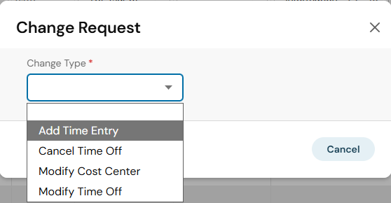

Then select the date of the OTC time, enter the TOTAL of 1, in the Extra Pay you need to click the dropdown and BROWSE. Select the CTO and it will be populated there the next time you try to add extra pay.
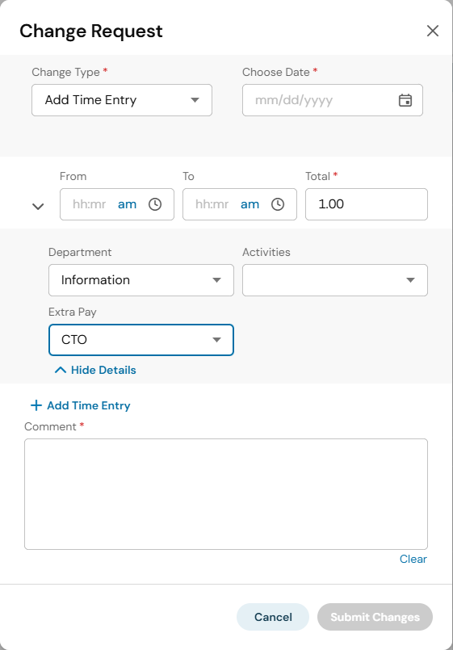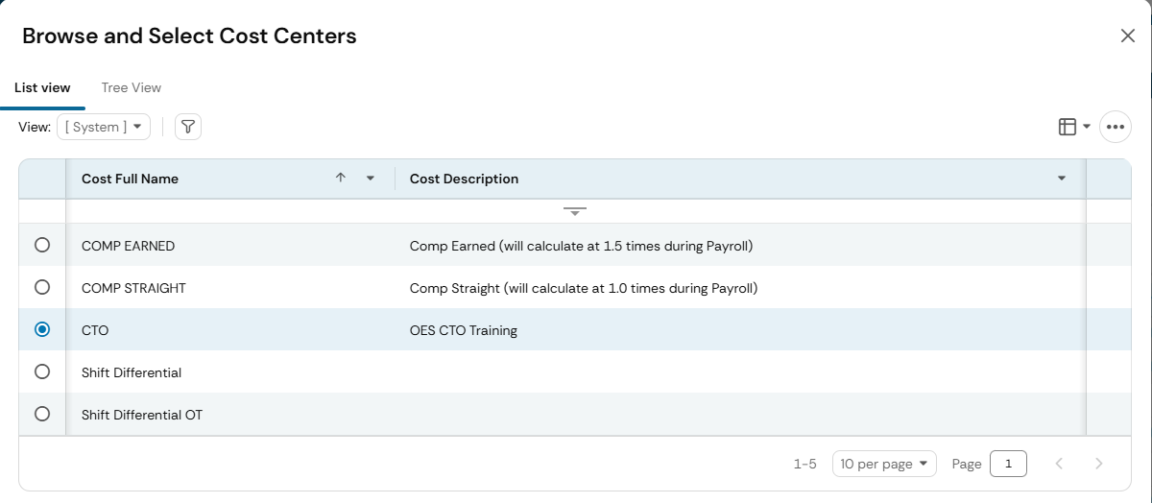
You must enter a comment to explain why you are submitting the change request or it will not allow you to use the submit button. Once submitted you will not see this entry on your timesheet until approved.
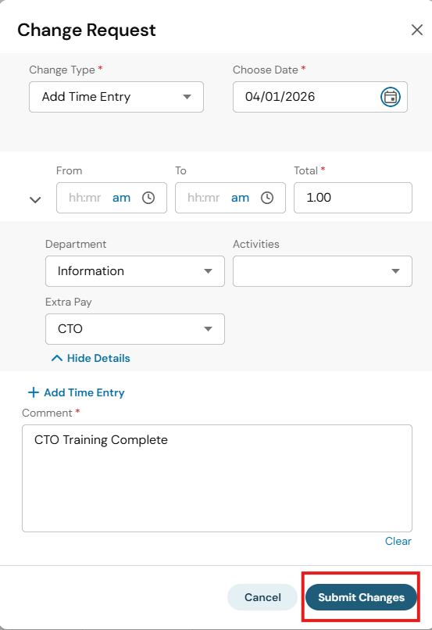

Punch In/Out
Note: This is only for employees who clock in/out and aren’t using a tablet or punch clock.
You can punch in or out directly from the home page by clicking Clock In or Clock Out. Once you’ve clocked in or out, you can view your punches by viewing your timesheet.
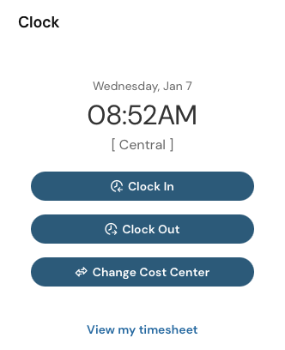
Alternatively, you can go to the Menu, click My Time > Clock, where you can Clock In or Out using the buttons provided.
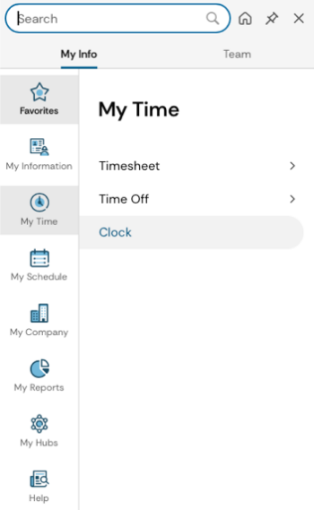

Request Time off
Requesting time off can be done a few different ways:
Option 1: From the Links space on the Home page. Under the My Time > Time Off section click on Request. Then on the following page, select a Time Off Type and then click Start Request.
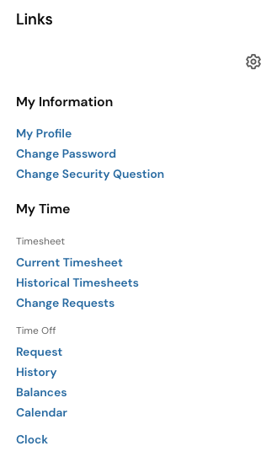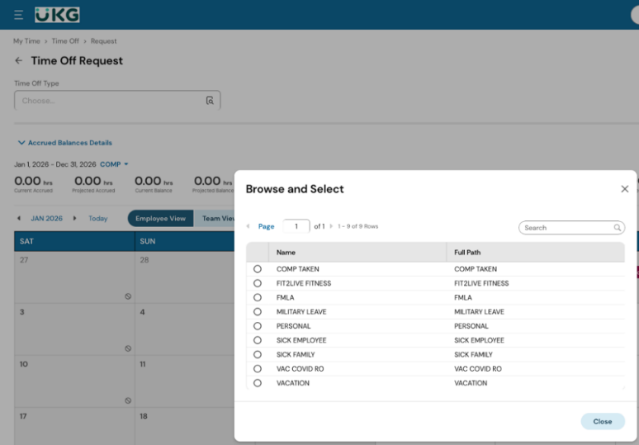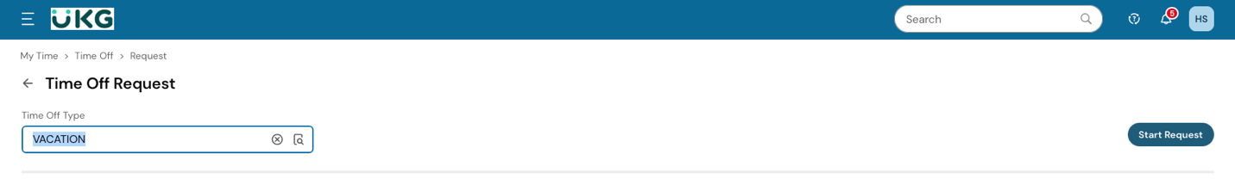Option 2: From the Links space on the Home page. Under the My Time > Time Off section click on Balances. Then on the following page, select the type of time off you want to request from the list.

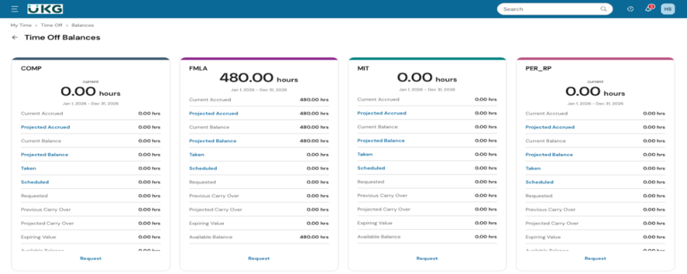
Option 3: From the Home page, look for the calendar and click “My time off”.
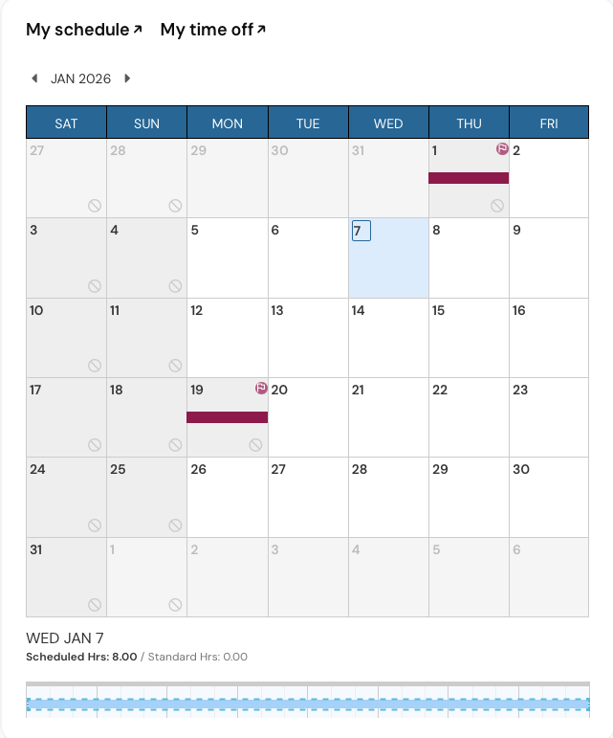

Once you’ve started the time off request, you will see a window where you can choose the request type:
Full Day – when you are requesting the entire workday off.
Multiple Days – when you are requesting multiple workdays off.
Partial Day (Bulk) – when you are requesting a number of hours off.
Partial Day (Start/Stop) – when you are requesting a specific time of the day off.
You will then select the day(s) and times you want off, add any comments for why you are requesting the time off, and then click Submit Request to send the request for approval by a Supervisor.
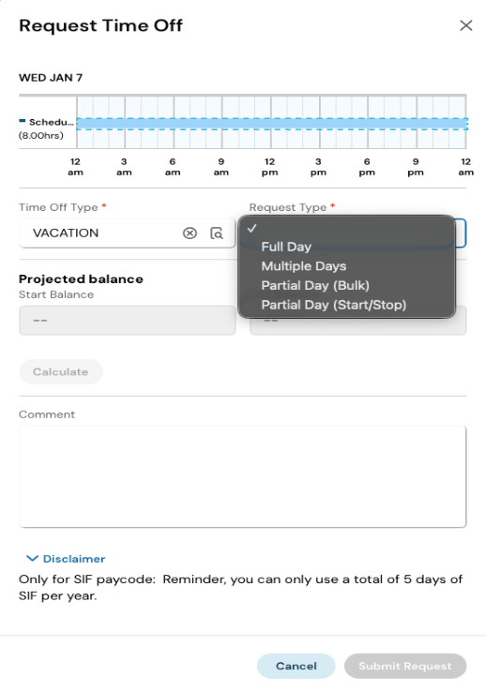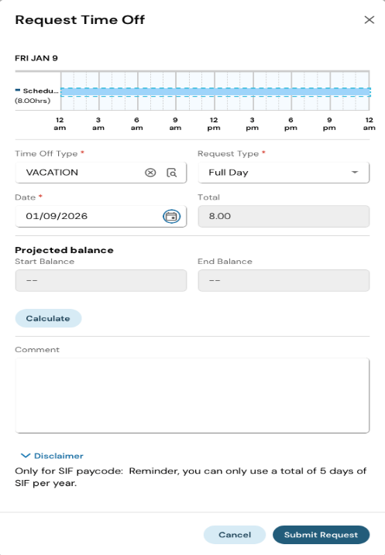
Note: After you select your time off, but before hitting Submit Request, you can hit the Calculate button to see how this request would affect your remaining leave balance.

View Employee Profile
To view your employee profile information, from the Links space on the Home page. Under My Information click on My Profile. Alternatively, you can click on your initials at the top left of the page. Your employee information is your basic account details. (I.e. Name, Department, Hire Date, Accrual Balances). You won’t need to regularly edit this information, but if you find any of it to be incorrect, you can let Human Resources know and they can correct it.
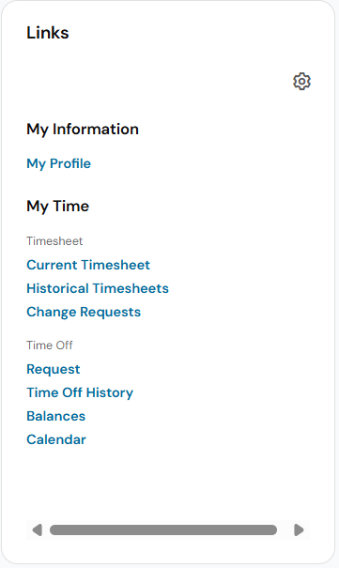

Payroll Clerks Tasks

Approving Timesheets
To view the current submitted timesheets that need approval, click on My Team tab then under the Links tab select Pending Approval under Time and Timesheets.
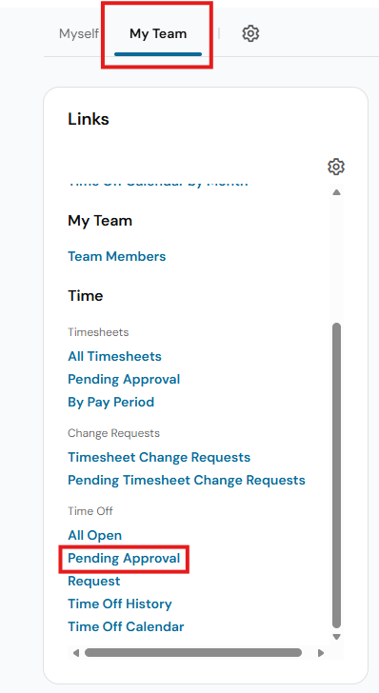
Alternatively, you can go the menu (three bars on the top left), click on Time > Timesheets > All Timesheets>Pending Approval.
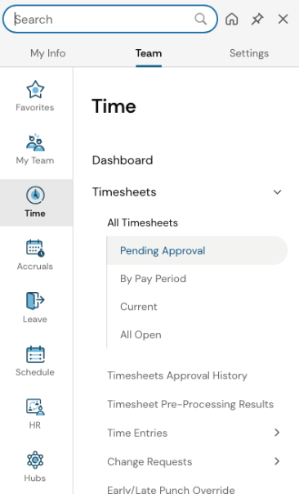
*Please note that when you log in to approve timesheets for the first time you may need to make some edits to the dates that are shown. *
If you see “No data available” you will need to adjust the timeframe of the timesheet.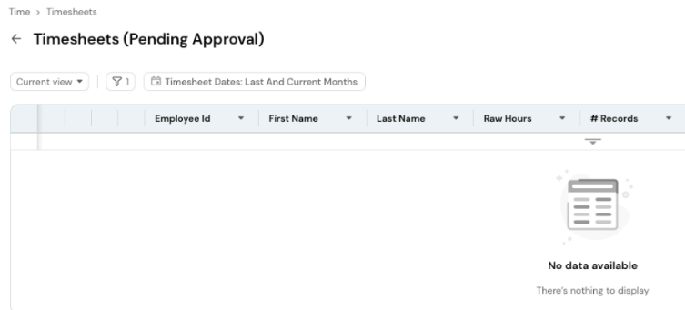
To make the changes that are needed to view the timesheet data you will need to click on Timesheet Dates. That will open a filter tab that will allow you to adjust the settings. Once the filter tab opens, change the Type to Pay Period, ensure that Profile is set to My Profile: Bi-Weekly, and Pay Period is set to Current and click apply at the bottom right of the tab. If you need to see the previous pay period, click on Pay Period and select Previous from the drop-down menu.
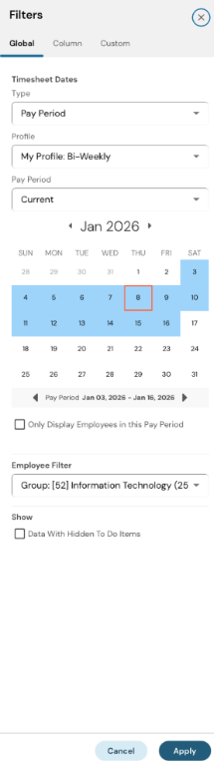
Then click save.

