UKG Ready: Employee Guide
Employee:
Employee Tasks 2
Go Back to Home page 2
View Menu / Pin Menu 3
View/Edit Current timesheets 4
View Current timesheet 4
View Historical Timesheets 5
Request Overtime as Comp time 7
CTO 9
Punch In/Out 11
Request Time off 12
View Employee Profile 15

Employee Tasks

Go Back to Home page
To go back to the Home page, you can click on the UKG logo. Alternatively, from the Menu (3 stacked lines) on the top left side of the screen, you can click the Home icon next to the search
bar.
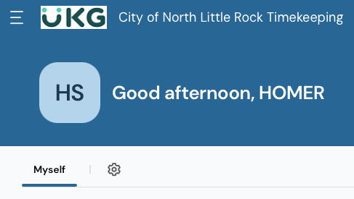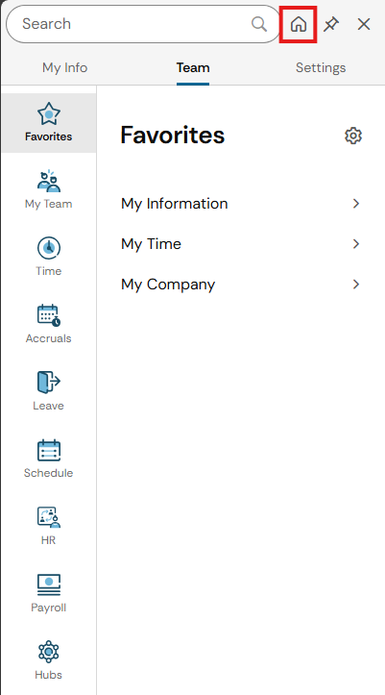

View Menu / Pin Menu
To view the Menu, you can click the 3 stacked lines on the top left of the page. To make this menu stay open, you can choose to pin it by clicking on the pin icon in the upper left near the search bar.
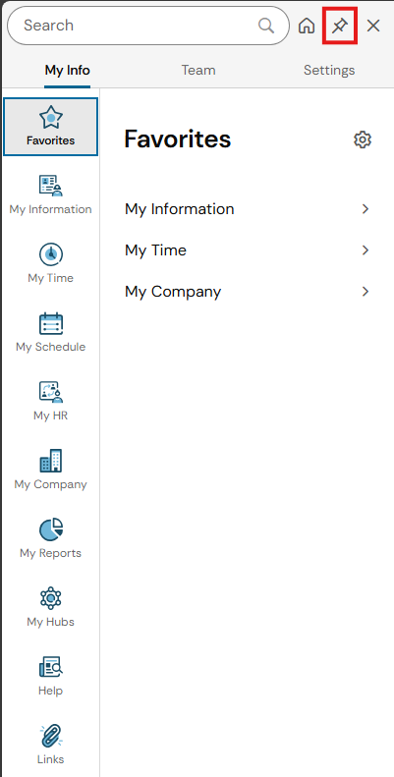
To unpin the Menu from the side, you can click the same pin icon that was used to pin the menu.

View/Edit Current timesheets

View Current timesheet
To view your current timesheet, click on View My Timesheet in the Clock widget on the Home page. Alternatively, you can go to the Menu, click on My Time > Timesheet > Current Timesheet.
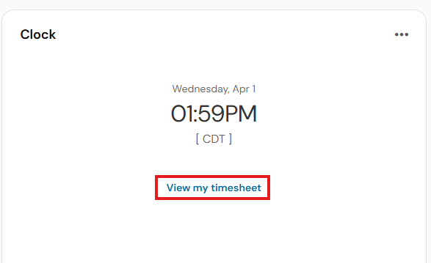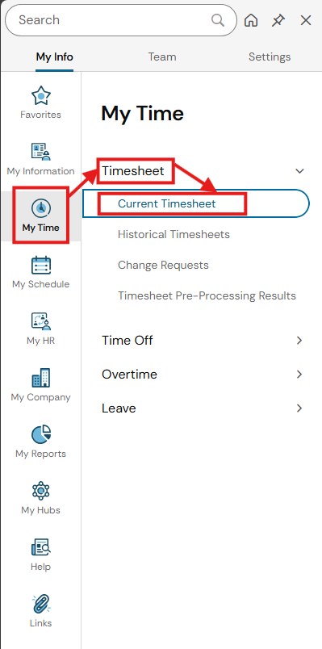

View Historical Timesheets
To view your historical timesheets, click on Historical Timesheet in the Links widget on the Home page (beneath the Clock widget), then click on Historical Timesheets. Alternatively, you can go the Menu, click on My Time > Timesheet > Historical Timesheets.
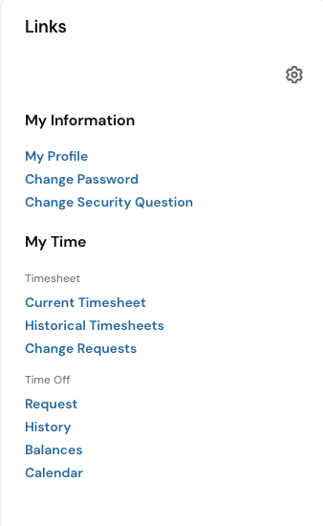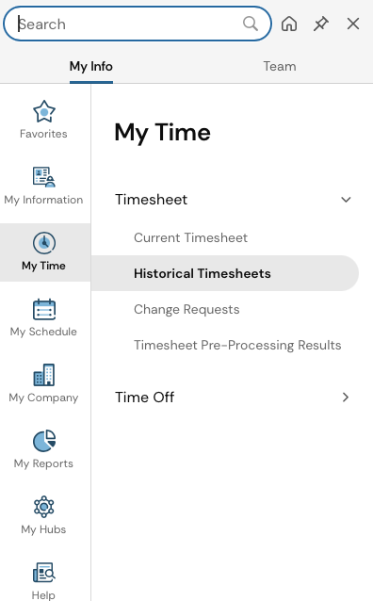
You will get a list of historical timesheets. You can click the pencil icon next to the one you want to view. If you want to view multiple, you can select the checkboxes next to the ones you want to view, then click on View at the top right of the page. Note: if you don’t see the timesheet you’re looking for, there may be several pages of timesheets. You will need to page through them to see more, using the arrows at the bottom of the page.
Option 1: View a single timesheet. Click the pencil next to the one you want.
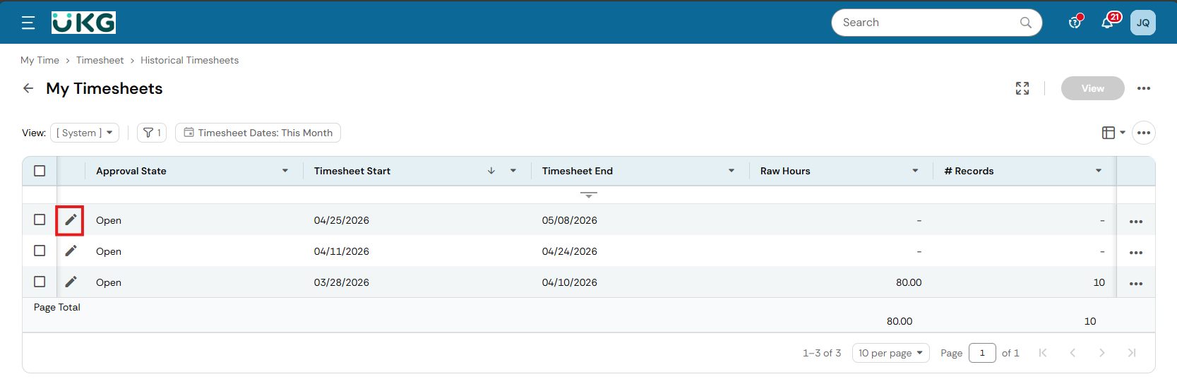

Option 2: View multiple timesheets. Check the checkbox next to the ones you want to view, then click View in the upper right.
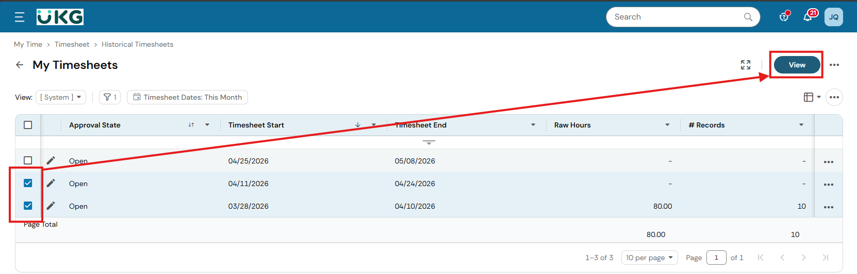

Request Overtime as Comp time
On the home page you can click the View My Timesheet button.
Select the Change Request button in the upper right.
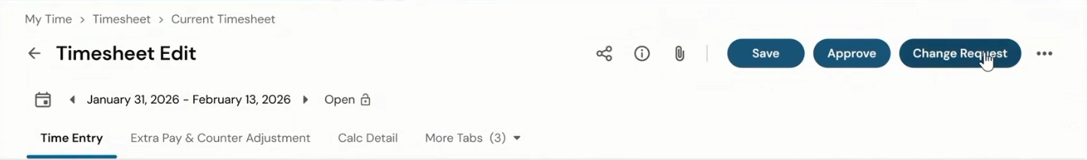
Select Add Time Entry from the drop-down box. Fill out the Date, TOTAL and Comment. Select the drop-down arrow to select an Activity. If you are looking for a specific activity and cannot find it, select Browse from the drop-down menu.
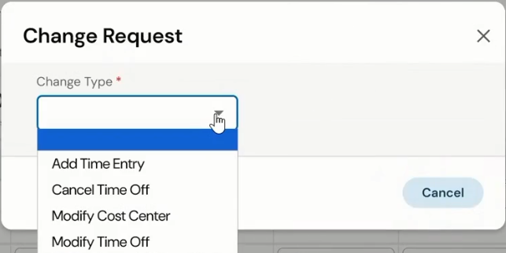
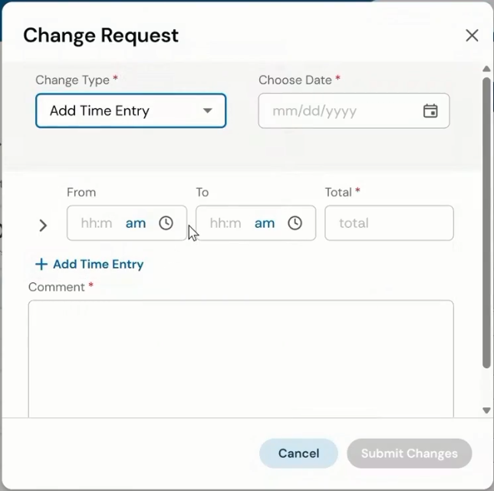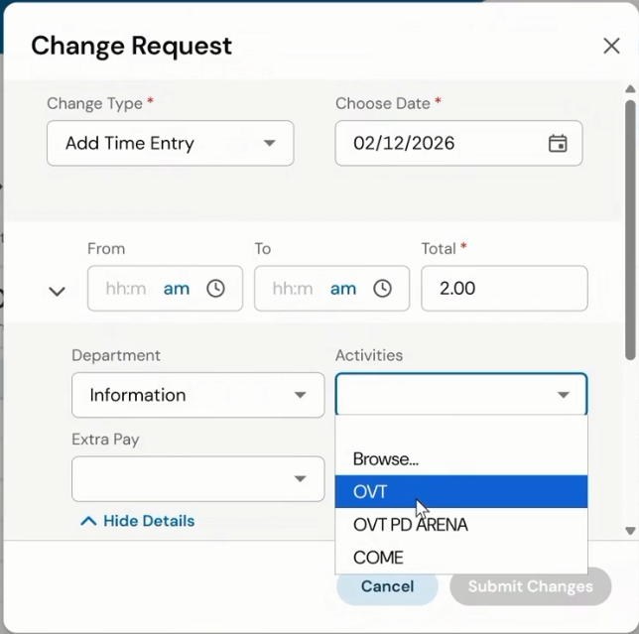

Scroll through the list for the wanted type.
Note: If no time has been taken off for the week, COME is a valid selection. If time has been taken off, pick COME_ST. OVT for standard over time as your department permits.
* Note for PD Users – The Browse and Select Cost Centers selection is where you can find the reimbursable overtimes (i.e. Dollar General, Arena, Mall etc.). You can browse using the list or in tree view.
* Note for OESN Users – This is where you would add OESN for any hours that qualify, that aren’t included in your standard work schedule.
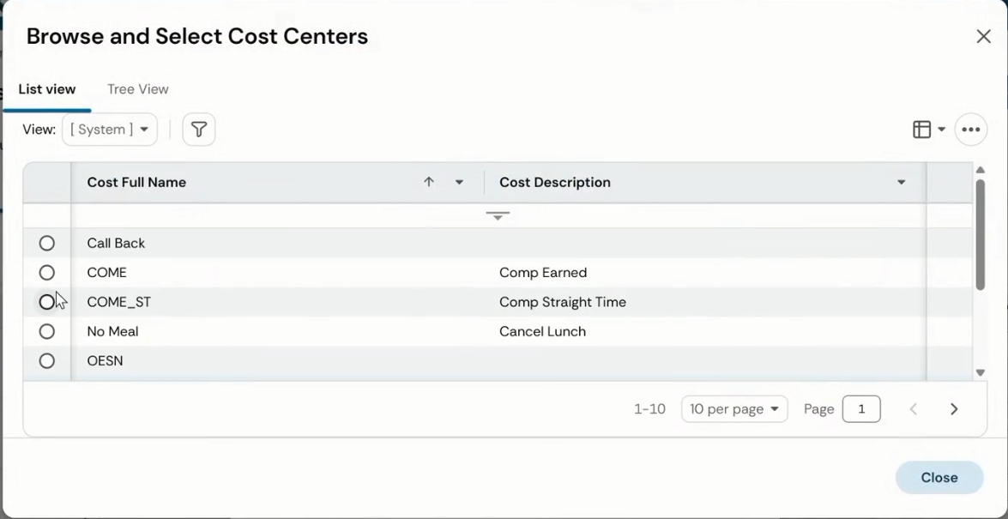
When entering time, enter it as the exact hours worked. BS&A will run the calculations and apply the correct multiplier based on the pay code type.
Once you submit changes you will not see the request on your time sheet until it is approved. If you need to check or adjust the submitted entry, select the Hamburger menu (triple line) at the top left and go to Change Requests.
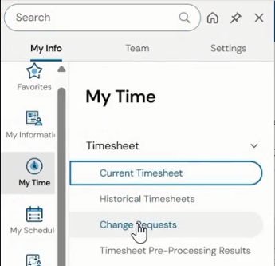
You’ll see one or many requests that haven’t been approved yet. You may adjust it from the TRIPLE dot on the right, or the EDIT pencil on the left.
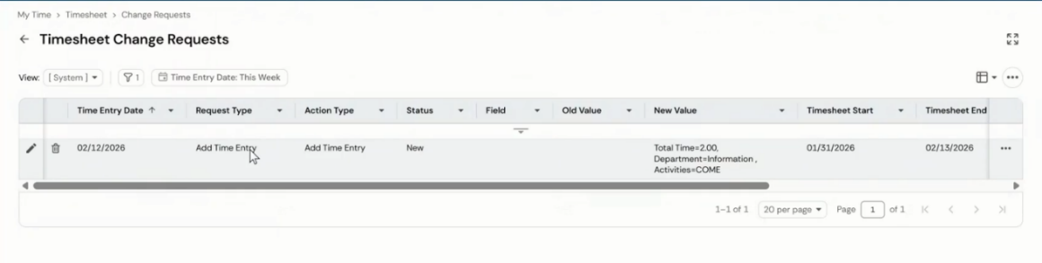

CTO
To submit your CTO time you need to create an entry on your Timesheet directly. You can access this on the main menu, on the clock, select View my timesheet.
Click Change Request.
Then in the Change Request window select Add Time Entry.
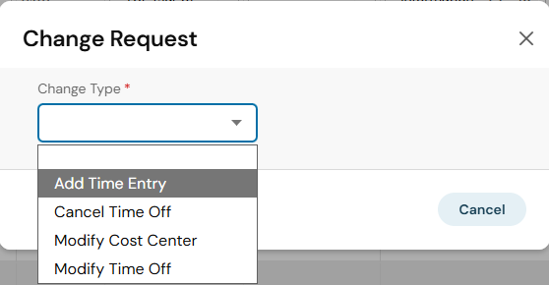
Then select the date of the OTC time, enter the TOTAL of 1, in the Extra Pay you need to click the dropdown and BROWSE. Select the CTO and it will be populated there the next time you try to add extra pay.
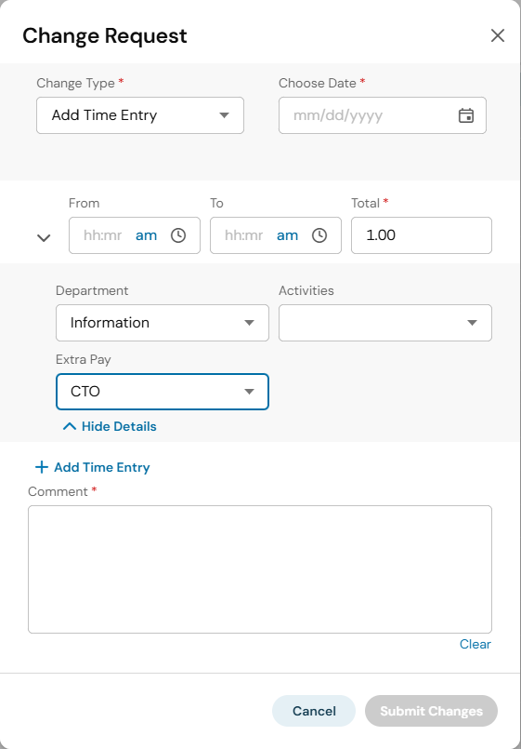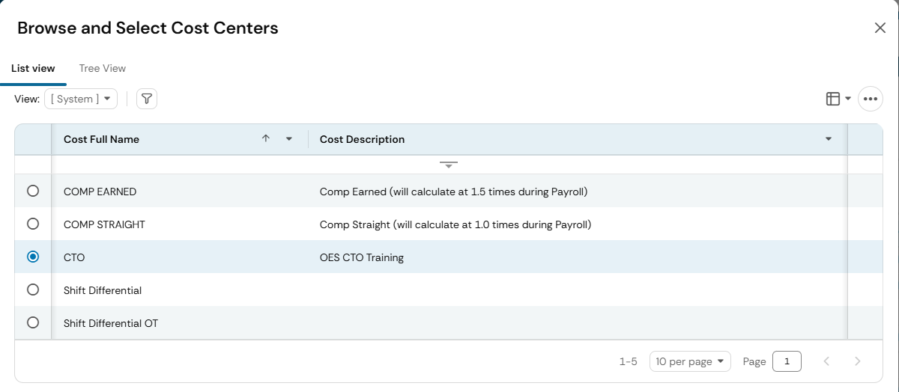
You must enter a comment to explain why you are submitting the change request or it will not allow you to use the submit button. Once submitted you will not see this entry on your timesheet until approved.
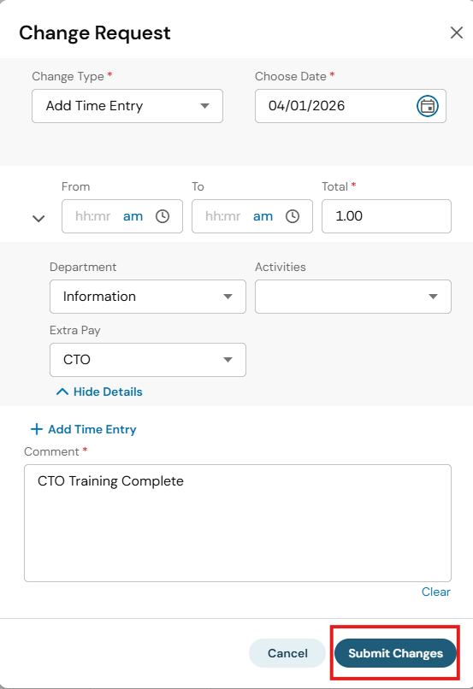

Punch In/Out
Note: This is only for employees who clock in/out and aren’t using a tablet or punch clock.
You can punch in or out directly from the home page by clicking Clock In or Clock Out. Once you’ve clocked in or out, you can view your punches by viewing your timesheet.
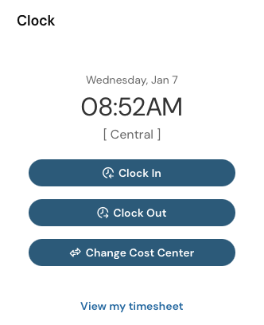
Alternatively, you can go to the Menu, click My Time > Clock, where you can Clock In or Out using the buttons provided.
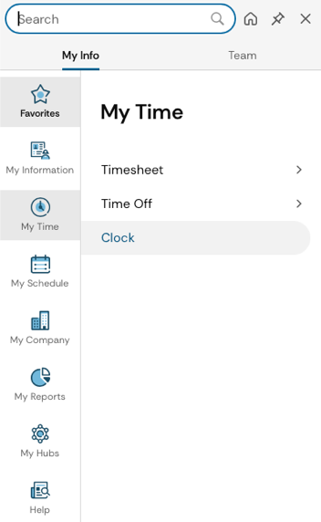

Request Time off
Requesting time off can be done in a few different ways:
Option 1: From the Links space on the Home page. Under the My Time > Time Off section click on Request. Then on the following page, select a Time Off Type and then click Start Request.
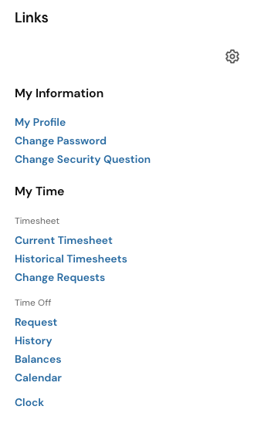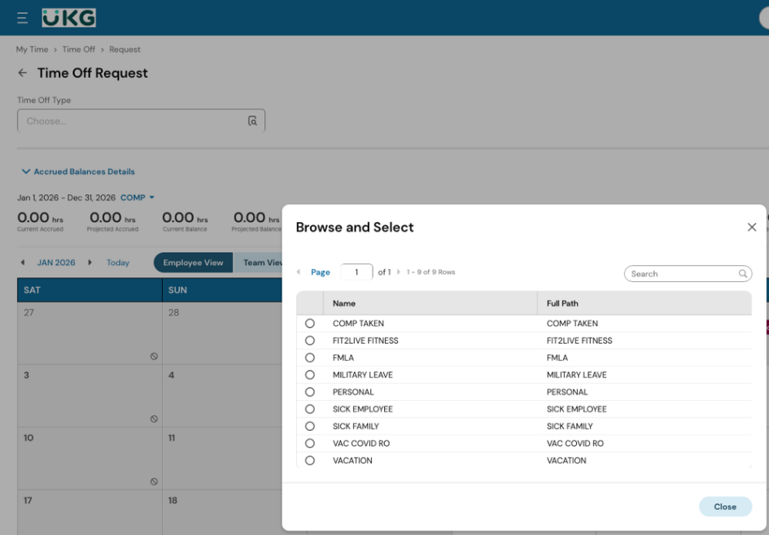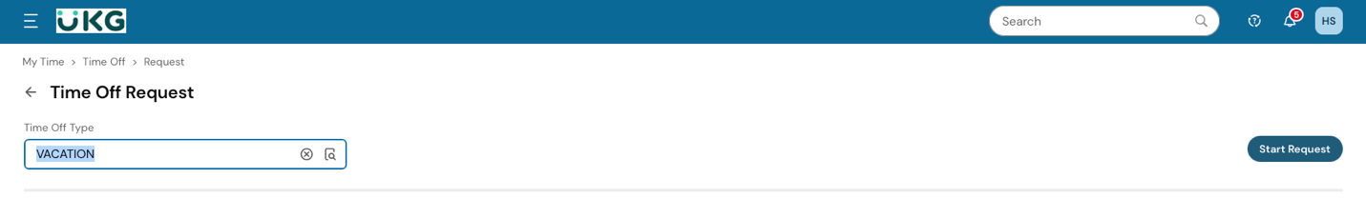

Option 2: From the Links space on the Home page. Under the My Time > Time Off section click on Balances. Then on the following page, select the type of time off you want to request from the list.

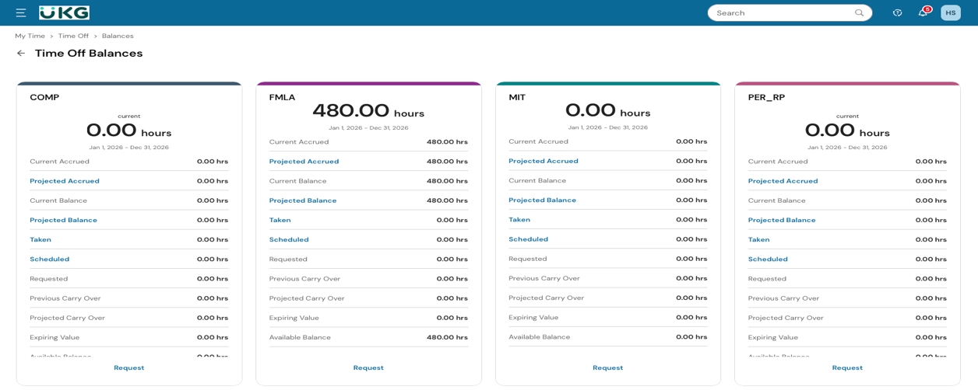
Option 3: From the Home page, look for the calendar and click “My time off”.
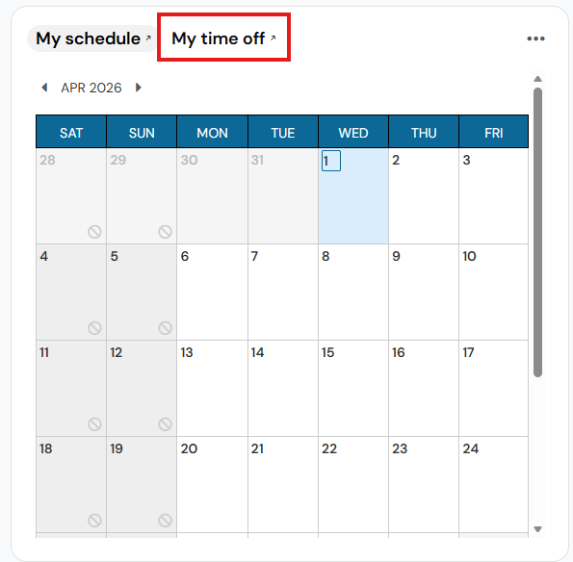

Once you’ve started the time off request. You will see a window where you can choose the request type:
- Full Day – when you are requesting the entire workday off.
- Multiple Days – when you are requesting multiple workdays off.
- Partial Day (Bulk) – when you are requesting a number of hours off.
- Partial Day (Start/Stop) – when you are requesting a specific time of the day off.
You will then select the day(s) and times you want off, add any comments for why you are requesting the time off, and then click Submit Request to send the request for approval by a Supervisor.
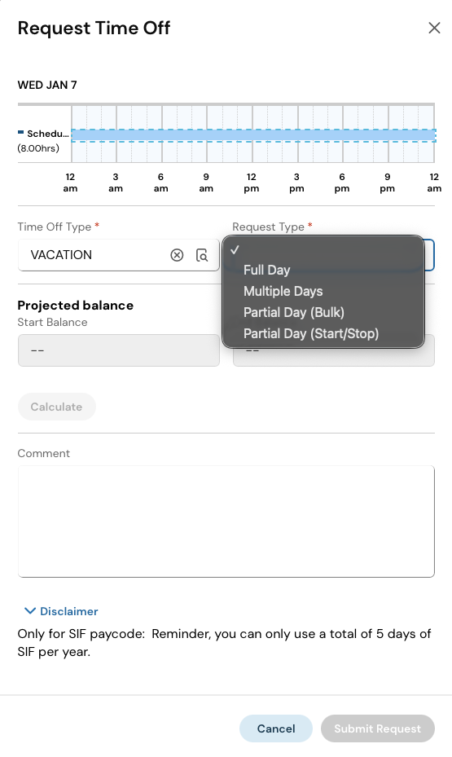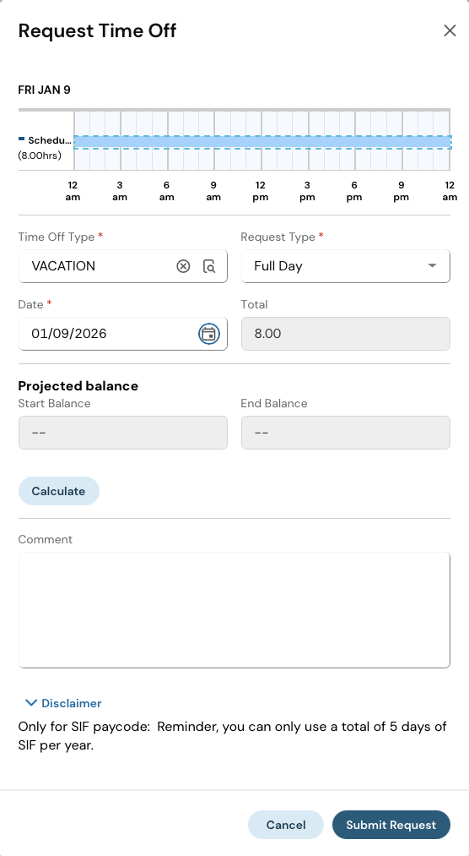
Note: After you select your time off, but before hitting Submit Request, you can hit the Calculate button to see how this request would affect your remaining leave balance.

View Employee Profile
To view your employee profile information, from the Links space on the Home page. Under My Information click on My Profile. Alternatively, you can click on your initials at the top left of the page. Your employee information is your basic account details. (I.e. Name, Department, Hire Date, Accrual Balances). You won’t need to regularly edit this information, but if you find any of it to be incorrect, you can let Human Resources know and they can correct it.
